**Jukebox Card for Home-Assistant**

This is a media player UI for Home-Assistant leveraging the potential of the excellent new [Lovelace UI.](https://www.home-assistant.io/lovelace/)

It allows you to configure a set of web radio stations (or possibly other radio media IDs such as spotify), and play them to media player entities of your choice, like chromecast or spotify connect listeners.

You can send different media to different players, which makes it usable for multi-room setups: Let your kids listen to some *Frozen*, while you're Jazzing in the Kitchen. Volume-Level is handled separately, too.

**Screenshot**

[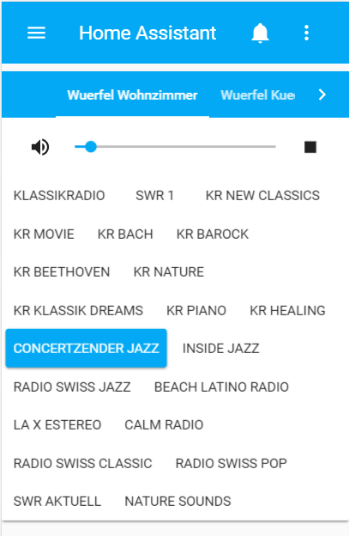](https://github.com/lukx/home-assistant-jukebox/blob/master/screenshot.png?raw=true)

**Acknowledgement**

Apart from the home-assistant project, I need to say thanks to User [Bob_NL](https://community.home-assistant.io/u/Bob_NL) who made his evergreen [Chromecast Radio](https://community.home-assistant.io/t/chromecast-radio-with-station-and-player-selection/12732) available to all of us in the Home-Assistant forums. This jukebox is heavily deriving from the great work of all the people in the thread.

**Usage**

**Installation using HACS**

I recommend using [HACS](https://hacs.xyz/) to install and update this integration. As the jukebox card is not yet in the official repositories of HACS, follow these steps to get it running:

* (Install HACS if you have not already; look into their documentation in the link above to achieve this)
* In your Home Assistant, open the HACS panel
* Click on "Frontend" to see the list of Frontend (or "Lovelace") integrations
* On the top right of your screen, click on the three dots to see "Custom Repositories"
* in the "Custom Repositories" dialogue, paste https://github.com/lukx/home-assistant-jukebox.git in the "custom repository URL" box, and select "Lovelace" as the Category.
* Now, in the Frontend Category, search for "Jukebox" and install this module like you would install any other module.

**Configuration**

**Find radio stations**

<https://www.radio-browser.info/>

**Setup**

Find stream URLs, e.g. on [Radio-Browser.info](http://www.radio-browser.info/gui/#/) See this example setting a couple of Web radios to my two chromecast players.

**Using lovlace in yaml mode**

*Excerpt of ui-lovelace.yaml*

resources:

- url: /hacsfiles/home-assistant-jukebox/jukebox-card.js

type: module

views:

- name: Example

cards:

- type: "custom:jukebox-card"

links:

- url: http://streams.greenhost.nl:8080/jazz

name: Concertzender Jazz

- url: http://fs-insidejazz.fast-serv.com:8282/;stream.nsv

name: Inside Jazz

- url: http://stream.srg-ssr.ch/m/rsj/mp3_128

name: Radio Swiss Jazz

- url: http://stream.beachlatinoradio.com:8030/;?d=

name: Beach Latino Radio

- url: http://streams.calmradio.com/api/43/128/stream/;?d=

name: Calm Radio

- url: http://swr-swr1-bw.cast.addradio.de/swr/swr1/bw/mp3/128/stream.mp3

name: SWR 1

- url: http://94.23.252.14:8067/stream

name: Nature Sounds

entities:

- media_player.wuerfel_wohnzimmer

- media_player.wuerfel_kueche

**Using lovelace UI**

* Go to the view you want to add the card, switch it to edit mode and click + add card
* Scroll all the way down and select Manual
* Paste your config and save

Example config (note the differances from the above example):

type: "custom:jukebox-card"

links:

- url: http://streams.greenhost.nl:8080/jazz

name: Concertzender Jazz

- url: http://fs-insidejazz.fast-serv.com:8282/;stream.nsv

name: Inside Jazz

- url: http://stream.srg-ssr.ch/m/rsj/mp3_128

name: Radio Swiss Jazz

- url: http://stream.beachlatinoradio.com:8030/;?d=

name: Beach Latino Radio

- url: http://streams.calmradio.com/api/43/128/stream/;?d=

name: Calm Radio

- url: http://swr-swr1-bw.cast.addradio.de/swr/swr1/bw/mp3/128/stream.mp3

name: SWR 1

- url: http://94.23.252.14:8067/stream

name: Nature Sounds

entities:

- media_player.wuerfel_wohnzimmer

- media_player.wuerfel_kueche